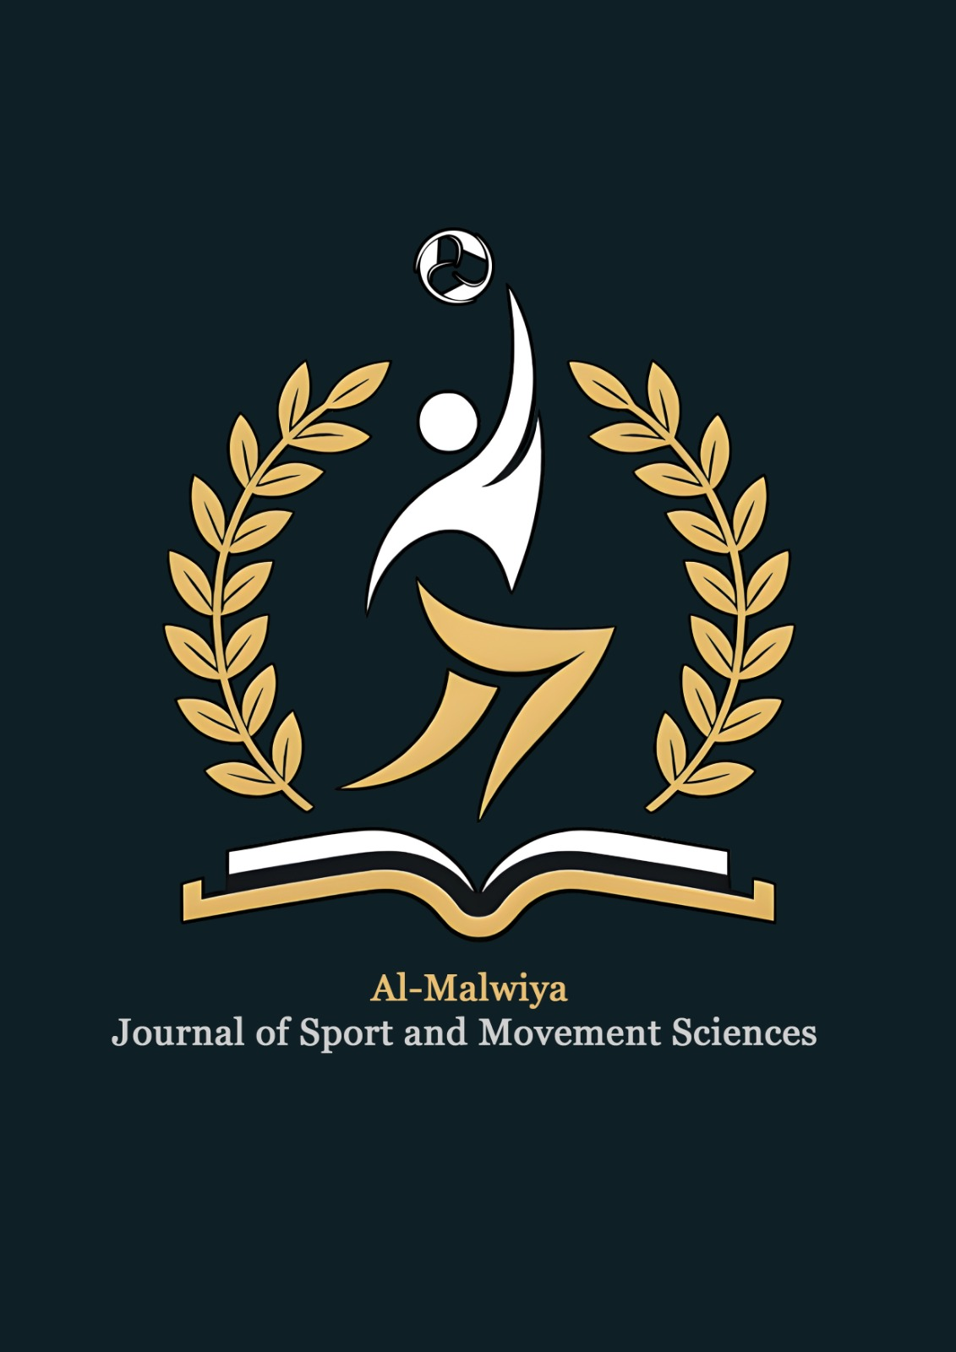 | Al-Malwiya Journal of Sport and Movement Sciences  Open Access · Peer Reviewed · Double-Blind Review · Iraq  amj-sms.com | ISSN (Online)  XXXX-XXXX  ISSN (Print)  XXXX-XXXX | Al-Malwiya  Academic Press  Al-Malwiya Academic Press  Published by the College of Physical Education and Sports Sciences, University of Samarra  Iraq · Est. 2026
Al-Malwiya J. Sport Mov. Sci. Vol. [1], No. [1] (2026) [pp–pp] https://doi.org/10.XXXXX/amjsms.20XX.XXXXX
Al-Malwiya Journal of Sport and Movement Sciences
FULL LENGTH ARTICLE
[Title of the Article: Replace this text with your manuscript title — concise and informative, reflecting the content of the study]
Ahmed K. Al-Rashidi ª, Omar F. Hassan ^{b}, Sana M. Ibrahim ^{a,*}
ª College of Physical Education and Sports Sciences, University of Samarra, Iraq | ^{b} College of Physical Education and Sports Sciences , University of Baghdad, Iraq | ^{C} College of Physical Education and Sports Sciences , University of Kirkuk, Iraq
*Corresponding author: s.ibrahim@uobaghdad.edu.iq
ARTICLE HISTORY  Received 12 January 2026  Revised 05 February 2026  Accepted 18 February 2026  Online 01 March 2026  KEYWORDS  3–6 keywords required  Agility  Athletic Performance  Explosive Power  Plyometric Training  Youth Football  SUBJECT AREA  Sport Sciences  Physical Education  Movement Analysis  © 20XX Al-Malwiya Academic Press. All rights reserved. Published under CC BY-NC-ND 4.0. AMJSMS | ABSTRACT  This study examined the effects of an eight-week plyometric training program on explosive power and agility in male youth football players. A randomized controlled design was employed, with thirty-two players (age: 16.4 ± 1.2 years; body mass: 67.3 ± 5.8 kg) randomly assigned to either a plyometric training group (PTG, n = 16) or a control group (CG, n = 16). The PTG performed three plyometric sessions per week in addition to their regular football training, while the CG continued with routine football practice only. Explosive power was assessed using the vertical jump test (VJT) and standing broad jump (SBJ), and agility was measured using the Illinois Agility Test (IAT) and the 5-10-5 shuttle run. Pre- and post-intervention assessments were conducted by blinded assessors. Independent and paired t-tests were used for statistical analysis (alpha = 0.05). Following the intervention, the PTG demonstrated significantly greater improvements in VJT (pre: 38.2 ± 3.6 cm vs. post: 46.5 ± 4.1 cm; p < 0.001; Cohen’s d = 2.13), SBJ (pre: 172.4 ± 12.3 cm vs. post: 189.7 ± 11.8 cm; p < 0.001; d = 1.44), and IAT (pre: 16.8 ± 0.9 s vs. post: 15.3 ± 0.7 s; p < 0.001; d = 1.88) compared to the CG. No significant changes were observed in the CG across any measure. These findings indicate that an eight-week structured plyometric program yields large and practically meaningful improvements in explosive power and agility among adolescent football players, supporting its integration into youth football conditioning protocols.

1. Introduction

Plyometric training has been widely recognized as an effective method for developing neuromuscular performance in sport. By employing rapid stretch-shortening cycle (SSC) movements, plyometric exercises enhance the capacity of muscles to generate explosive force in minimal time (Markovic & Mikulic, 2010). These adaptations are particularly relevant in football, where explosive actions such as sprinting, jumping, and rapid directional changes are frequently performed during match play (Stolen et al., 2005). Given the increasing physical demands placed on young players in competitive football, identifying evidence-based conditioning strategies that safely and effectively enhance these motor qualities is of considerable practical importance.
Previous research has demonstrated that plyometric training produces significant improvements in vertical jump height, sprint speed, and change-of-direction ability in adult athletes (Ramirez-Campillo et al., 2015; Meylan & Malatesta, 2009). However, evidence relating specifically to youth football players remains comparatively limited, and methodological inconsistencies across studies—including variation in training duration, volume, and intensity—make it difficult to draw firm conclusions about optimal program parameters for adolescent populations (Lloyd et al., 2012). Furthermore, agility, which encompasses both reactive and planned change-of-direction capacity, has received less attention than vertical jump performance in the plyometric literature, despite its centrality to football performance (Sheppard & Young, 2006).
The purpose of this study was therefore to investigate the effects of an eight-week plyometric training program, integrated within regular football practice, on explosive power and agility in male youth football players. It was hypothesized that the plyometric training group would exhibit significantly greater improvements in vertical jump, standing broad jump, and agility test performance compared to a control group receiving standard football training only.
2. Materials and Methods
This study employed a randomized controlled experimental design to examine the effects of plyometric training on explosive power and agility in youth football players over an eight-week intervention period
2.1. Study Design
A randomized controlled trial design was adopted. Following baseline assessments, participants were randomly allocated using a computer-generated randomization list to either the plyometric training group (PTG) or the control group (CG). The study was approved by the Research Ethics Committee of the University of Baghdad, College of Physical Education and Sport Sciences (Approval No. UOB-PESS-2025-047) and conducted in accordance with the Declaration of Helsinki. Written informed consent was obtained from all participants and their legal guardians prior to enrolment.
2.2. Participants
Thirty-two male youth football players were recruited from two affiliated football academies in Baghdad, Iraq. Eligibility criteria required participants to be aged 15–18 years, registered members of a competitive football academy for at least one year, free from musculoskeletal injury for the preceding six months, and not engaged in any supplementary strength or plyometric conditioning program. Participants were excluded if they had any cardiovascular or metabolic contraindications to high-intensity exercise. The sample (age: 16.4 ± 1.2 years; height: 174.6 ± 5.3 cm; body mass: 67.3 ± 5.8 kg) was randomly divided into PTG (n = 16) and CG (n = 16), with no significant between-group differences at baseline (p > 0.05).
2.3. Procedures and Instruments
All testing was conducted at the university’s indoor sports hall under standardized conditions (temperature: 22–24°C). Pre- and post-tests were performed on the same day of the week, at the same time of day, by blinded assessors. The PTG performed three plyometric sessions per week (Monday, Wednesday, Friday) integrated within the regular 90-minute football training session, for eight weeks. Sessions were supervised by a certified strength and conditioning specialist. The plyometric protocol included depth jumps, box jumps, lateral bounds, hurdle hops, and single-leg hops, progressing systematically in volume and intensity across the eight weeks. The CG continued their regular football training without any plyometric exercises. Explosive power was assessed using (1) the Vertical Jump Test (VJT), measured with a Vertec jump measurement device (Sports Imports, Columbus, OH, USA), and (2) the Standing Broad Jump (SBJ), measured with a standard measuring tape. Agility was assessed using (3) the Illinois Agility Test (IAT), timed with a dual-beam electronic timing gate (Brower Timing Systems, Draper, UT, USA), and (4) the 5-10-5 Pro Agility Shuttle Run. Each test was performed twice with a three-minute rest interval between attempts, and the best value was retained for analysis.
2.4. Statistical Analysis
Data were analyzed using IBM SPSS Statistics (Version 26.0; IBM Corp., Armonk, NY, USA). Normality of distribution was confirmed via the Shapiro–Wilk test (p > 0.05 for all variables). Descriptive statistics (mean ± SD) were calculated for all outcome measures. Paired-samples t-tests were used to assess within-group changes (pre vs. post), and independent-samples t-tests evaluated between-group differences in change scores. Effect sizes were calculated using Cohen’s d, with thresholds of small (0.20), medium (0.50), and large (0.80) as defined by Cohen (1988). The alpha level for statistical significance was set at p < 0.05 for all comparisons.
3. Results
AII thirty-two participants completed the eight-week intervention with full adherence (100% session attendance). No adverse events or injuries were reported during the study period. Baseline characteristics did not differ significantly between groups for any measured variable (p > 0.05). Results of pre- and post-intervention comparisons for all outcome measures are presented below Within the PTG, significant improvements were observed in all four performance measures following the eight-week plyometric program (p < 0.001 for all). Vertical jump height increased from 38.2 ± 3.6 cm to 46.5 ± 4.1 cm (mean difference: +8.3 cm; 95% CI: 6.7–9.9; Cohen’s d = 2.13). Standing broad jump improved from 172.4 ± 12.3 cm to 189.7 ± 11.8 cm (mean difference: +17.3 cm; 95% CI: 13.8–20.8; d = 1.44). Illinois Agility Test time decreased from 16.8 ± 0.9 s to 15.3 ± 0.7 s (mean difference: −1.5 s; 95% CI: −1.9 to −1.1; d = 1.88), and 5-10-5 shuttle run time improved from 4.92 ± 0.21 s to 4.56 ± 0.18 s (mean difference: −0.36 s; 95% CI: −0.44 to −0.28; d = 1.85). In contrast, no statistically significant changes were recorded in the CG for any variable (p > 0.05). Between-group comparisons of change scores confirmed that the PTG exhibited significantly greater gains than the CG across all measures (p < 0.001). Full descriptive statistics are presented in Table 1.

Table 1. Pre- and post-intervention performance outcomes for the Plyometric Training Group (PTG) and Control Group (CG) (Mean ± SD).
Variable | Plyometric Training Group (PTG, n = 16) |  |  |  | Control Group (CG, n = 16)
Outcome Measure | Pre | Post | Δ | d | Pre | Post | p
VJT (cm) | 38.2 ± 3.6 | 46.5 ± 4.1 | +8.3 | 2.13 | 37.9 ± 3.4 | 38.3 ± 3.5 | > 0.05
SBJ (cm) | 172.4 ± 12.3 | 189.7 ± 11.8 | +17.3 | 1.44 | 171.8 ± 11.9 | 172.6 ± 12.1 | > 0.05
IAT (s) | 16.8 ± 0.9 | 15.3 ± 0.7 | −1.5 | 1.88 | 16.9 ± 0.8 | 16.7 ± 0.8 | > 0.05
5-10-5 Shuttle (s) | 4.92 ± 0.21 | 4.56 ± 0.18 | −0.36 | 1.85 | 4.95 ± 0.19 | 4.93 ± 0.20 | > 0.05
Note. VJT = Vertical Jump Test; SBJ = Standing Broad Jump; IAT = Illinois Agility Test; Δ = mean difference (Post − Pre); d = Cohen’s d effect size; SD = standard deviation. All PTG within-group changes: p < 0.001. All CG within-group changes: p > 0.05.

Table 2. Baseline participant characteristics for the PTG and CG (Mean ± SD).
Characteristic | PTG (n = 16) | CG (n = 16)
Age (years) | 16.3 ± 1.1 | 16.5 ± 1.3
Height (cm) | 175.2 ± 5.1 | 174.1 ± 5.5
Body mass (kg) | 67.1 ± 5.6 | 67.5 ± 6.0
Training experience (years) | 3.4 ± 0.8 | 3.6 ± 0.9
Note. No significant between-group differences were observed at baseline for any variable (independent samples t-test, p > 0.05 for all). PTG = Plyometric Training Group; CG = Control Group; SD = standard deviation.
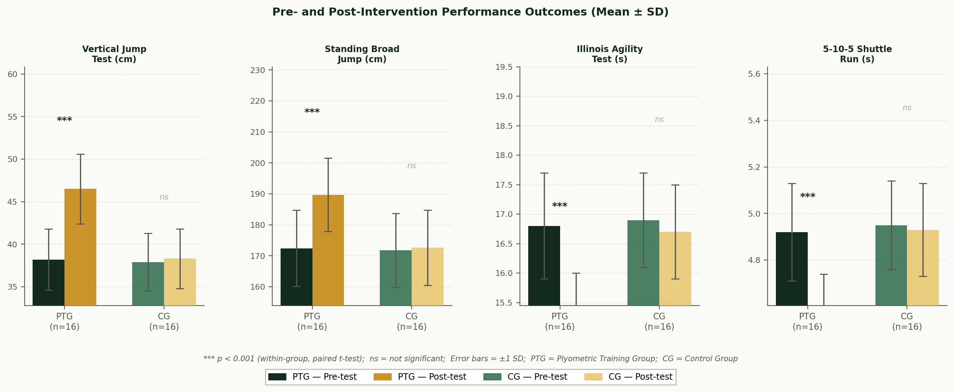
Figure 1. Pre- and post-intervention mean scores (± SD) for each performance test in the Plyometric Training Group (PTG) and Control Group (CG). *** p < 0.001 (within-group change, paired t-test); ns = not significant; PTG = Plyometric Training Group; CG = Control Group.
4. Discussion
The primary finding of this study was that an eight-week plyometric training program, integrated within standard football training, produced large and statistically significant improvements in explosive power and agility in male youth football players, while no meaningful changes were observed in the control group. These results support the hypothesis that structured plyometric conditioning offers a meaningful supplement to conventional football practice for enhancing key physical performance attributes in adolescent players The magnitude of improvement in vertical jump performance (Cohen’s d = 2.13) observed in the PTG is consistent with, and somewhat exceeds, effect sizes reported in prior meta-analyses of plyometric interventions in youth athletes (Ramirez-Campillo et al., 2015; Meylan & Malatesta, 2009). This may be partly attributable to the relatively untrained status of the participants at baseline, which is known to amplify training-induced adaptations (Lloyd et al., 2012). The improvements in agility, as indexed by the IAT (d = 1.88) and the 5-10-5 shuttle (d = 1.85), are also substantial and align with evidence that plyometric exercises improve reactive neuromuscular control through enhanced muscle spindle sensitivity and rate of force development (Markovic & Mikulic, 2010).
Our findings are broadly in agreement with Meylan and Malatesta (2009), who reported significant gains in jump height and sprint performance following a six-week in-season plyometric program in young male football players. Similarly, Ramírez-Campillo et al. (2015) demonstrated that bi-weekly plyometric training over ten weeks produced meaningful improvements in explosive power and agility in Chilean youth footballers. The present study extends this evidence by demonstrating comparably large effect sizes over a slightly shorter intervention duration (eight weeks) and with a more rigorous randomized controlled design, addressing a methodological limitation noted in several earlier studies. Notably, the absence of any significant change in the CG across all measures confirms that the observed improvements were attributable to the plyometric intervention rather than natural maturation or seasonal training effects.
From a practical standpoint, the protocol used in the present study—three weekly sessions of 20–30 minutes of plyometric exercises embedded within regular football training—is both time-efficient and feasible within typical academy training schedules. Coaches and sport scientists working with youth football populations can implement similar programs without significantly disrupting established technical and tactical training commitments. The progressive nature of the program, which increased in intensity over the eight weeks, also reflects best-practice guidelines for safe plyometric loading in adolescent athletes (Lloyd et al., 2012).
Several limitations of the present study should be acknowledged. First, the sample was drawn exclusively from male players in Baghdad, which limits the generalizability of findings to female athletes or players from other cultural or competitive contexts. Second, the study did not include measures of reactive agility, which incorporates a decision-making component and may be more representative of match-play demands. Third, long-term retention of training adaptations was not assessed, and future research should examine whether gains are maintained across a full competitive season. Finally, the relatively small sample size (n = 16 per group) may have limited statistical power for detecting smaller effect sizes.
5. Conclusions
This randomized controlled trial provides robust evidence that an eight-week plyometric training program, delivered three times per week within regular football training sessions, significantly improves explosive power and agility in male youth football players. Large effect sizes were observed across all four performance outcomes—vertical jump, standing broad jump, Illinois Agility Test, and 5-10-5 shuttle run—in the plyometric training group, with no meaningful changes recorded in the control group. These findings carry direct practical implications for youth football coaches and sport scientists, supporting the structured integration of plyometric conditioning into academy training programs. Future research should examine the long-term retention of these adaptations, evaluate the efficacy of the protocol in female youth footballers, and incorporate reactive agility assessments to capture the decision-making dimension of sport-specific agility.
Author Contributions
A.K. Al-Rashidi: Conceptualization, Methodology, Investigation, Writing – Original Draft. O.F. Hassan: Data Curation, Formal Analysis, Visualization. S.M. Ibrahim: Supervision, Writing – Review & Editing, Project Administration. All authors have read and approved the final manuscript.
Acknowledgements
The authors would like to thank the football academies in Baghdad for their cooperation and the participants for their voluntary involvement in this study. The authors also acknowledge the support of the College of Physical Education and Sports Sciences, University of Samarra, in facilitating access to laboratory facilities and testing equipment throughout the study period.
Funding
This research received no specific grant from any funding agency in the public, commercial, or not-for-profit sectors.
Conflict of Interest
The authors declare that they have no known competing financial interests or personal relationships that could have appeared to influence the work reported in this paper.
Data Availability Statement
The data that support the findings of this study are available from the corresponding author upon reasonable request.

References
Cohen, J. (1988). Statistical power analysis for the behavioral sciences (2nd ed.). Lawrence Erlbaum Associates.
Lloyd, R. S., Oliver, J. L., Hughes, M. G., & Williams, C. A. (2012). Age-related differences in the neural regulation of stretch-shortening cycle activities in male youths during maximal and sub-maximal hopping. Journal of Electromyography and Kinesiology, 22(1), 37–43. https://doi.org/10.1016/j.jelekin.2011.09.008
Markovic, G., & Mikulic, P. (2010). Neuro-musculoskeletal and performance adaptations to lower-extremity plyometric training. Sports Medicine, 40(6), 449–495. https://doi.org/10.2165/11533420-000000000-00000
Meylan, C., & Malatesta, D. (2009). Effects of in-season plyometric training within soccer practice on explosive actions of young players. Journal of Strength and Conditioning Research, 23(9), 2605–2613. https://doi.org/10.1519/JSC.0b013e3181b1f019
Ramírez-Campillo, R., Burgos, C., Henríquez-Olín, C., Andrade, D. C., Martínez, C., Alvarez, C., Baez, E. I., Acuña, M., Marques, M. C., & Izquierdo, M. (2015). Effect of unilateral, bilateral, and combined plyometric training on explosive and endurance performance of young soccer players. Journal of Strength and Conditioning Research, 29(5), 1317–1328. https://doi.org/10.1519/JSC.0000000000000762
Sheppard, J. M., & Young, W. B. (2006). Agility literature review: Classifications, training and testing. Journal of Sports Sciences, 24(9), 919–932. https://doi.org/10.1080/02640410500457109
Stølen, T., Chamari, K., Castagna, C., & Wisløff, U. (2005). Physiology of soccer: An update. Sports Medicine, 35(6), 501–536. https://doi.org/10.2165/00007256-200535060-00004

