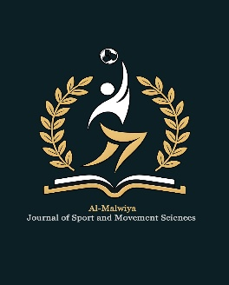 |   AL-MALWIYA JOURNAL OF SPORT  AND MOVEMENT SCIENCES
 | Journal homepage: amj-sms.com |  | Al-Malwiya J. Sport Mov. Sci. · Vol. 1, No. 1 (2026)
 | ISSN 3135-9973 (Online) |  | DOI:
Title
Name ª
ª College of Physical Education and Sports Sciences, University of Samarra, Iraq
*Corresponding author:

ARTICLE HISTORY |  | ABSTRACT
Received  Revised  Accepted  Online |  | ABSTRACT
KEYWORDS: |  | ABSTRACT
SUBJECT AREA: |  | ABSTRACT
LICENSE  © 2026 The Author(s). Published by Al-Malwiya Journal of Sport and Movement Sciences under the Creative Commons Attribution 4.0 International License (CC BY 4.0). |  | ABSTRACT

Introduction

Materials and Methods

Results

Table 1. Title of table (place table title ABOVE the table).
Figure 1. Title of figure (place figure title BELOW the figure).
Discussion

Conclusions
Acknowledgements
The authors extend sincere thanks to the athletes and coaching staff of the University of Samarra Football Programme for their cooperation and voluntary participation throughout the study period. The authors also acknowledge the technical support provided by the Sports Science Laboratory of the College of Physical Education and Sports Sciences, University of Samarra.
Funding
This research received no specific grant from any funding agency in the public, commercial, or not-for-profit sectors.
Conflict of Interest
The authors declare that they have no known competing financial interests or personal relationships that could have appeared to influence the work reported in this paper.
References

